|  |  |  |
| --- | --- | --- |
|  |  |  |

Symphony Limited

Design Document – Semester III

|  |  |  |  |
| --- | --- | --- | --- |
| **Guild Teacher :** | Phan Minh Tâm | | |
| **Class :** | GC0862 | | |
| **Group :** | 1 | | |
| **Group’s Members:** | Full Name | | Enrollment No. |
|  | 1. | Võ Minh Nhựt | Student687836 |
|  | 2. | Trần Nguyễn Công Nguyên | Student687854 |
|  | 3. | Nguyễn Ngọc Kiều Trinh | Student687822 |
|  | 4. | Đỗ Ngọc Quý | Student687813 |
|  |  |  |  |

# <11 – 2013>

Symphony Limited

Design Document – Semester III

|  |  |  |  |
| --- | --- | --- | --- |
| **Guild Teacher :** | Phan Minh Tâm | | |
| **Class :** | GC0862 | | |
| **Group :** | 1 | | |
| **Group’s Members:** | Full Name | | Enrollment No. |
|  | 1. | Võ Minh Nhựt | Student687836 |
|  | 2. | Trần Nguyễn Công Nguyên | Student687854 |
|  | 3. | Nguyễn Ngọc Kiều Trinh | Student687822 |
|  | 4. | Đỗ Ngọc Quý | Student687813 |
|  |  |  |  |

# <11 – 2013>

 

This is to certify that

**Mr. VO MINH NHUT**

**Mr. TRAN NGUYEN CONG NGUYEN**

**Ms. NGUYEN NGOC KIEU TRINH**

**Mr. DO NGOC QUY**

Have successfully Designed & Developed

**SYMPHONY LIMITED**

Submitted by:

**PHAN MINH TAM**

Date of Issue: 23-Nov-2013

Authorized Signature:

 

--Menu of Contents--

|  |  |
| --- | --- |
| Page | Contents |
| *Review 1* | |
| 5-7 | Problem Definition |
| 8-11 | Customer Requirement Specfication |
| 12 | Task Sheet 1 |
| *Review 2* | |
| 13-18 | Data Flow Diagram |
| 19-20 | UseCase Diagram |
| 21-26 | UseCase Description |
| 27-36 | Sequence Diagram |
| 37 | Entity Relationship Diagram |
| 38-42 | Entity Properties |
| 43-46 | Table Design |
| 47 | Database Relation Diagram |
| 48 | Class Diagram |
| 49 | Task Sheet 2Screenshots |
| Re *Review 3* | |
| 50-85 | jhhFFFHKFFSubmission Ch Flowcharts ecklist |
| 86 | SiteMap |
| 87-107 | GuideDesign |
| 108 | Checklist Of Validation |
| 109 | Sumission Validation |
| 110 | Task Sheet 3 |

**PROBLEM DEFINITION**

**❖ Introduction**

-Symphony Ltd. is private institute, which generally conducts the classes and training materials for the various certifications that are related to IT and Software industries like networking related, Java related, database related like for SQL Servers, oracle, etc. They are one of the famous institutions which have spread in to various branches situated at different location in the state.

-They provide various resources like the preparation materials, lab facilities based on the subject, extra lab hours or sessions (offered after the course duration), 24 hours faculty guidance is provided for the lab sessions, assignments, Library facilities, etc.

**❖ Existing Scenario**

- Currently they advertise about the services that they provide through the pamphlets (available at the centres), advertisements in news papers, and through other media like through television advertisements, etc. in order to attract the people. Usually they conduct the trainings on half yearly basis every year.

-They generally conduct an entrance exam through which they can know the knowledge level of the participant and thus depending on the exam marks they segregate the participants or the students into the appropriate class rooms like for the participant not having the minimum knowledge will be given training right from the basics till the certification level and for the participants having the minimum knowledge about the basics will be segregated in to the class where they direct start with the basic certification topics with out touching the basic concepts of the subject.

-Once the examination results are out, they inform the participants with the results, and ask them to visit the institution on a particular date for counseling purpose, where they inform the students with which class they will be segregated and regarding the course fees based on the class segregated. If the student is interested in taking the class, then he will be provided with the class form in which he/she is segregated and then they are directed to the accounts department where the student needs to make the payment in order to join the class. The student can make the payment for the class, at least 1 day before the commencement of the class.

-For the training with the basics they usually charge around 6000$, and the duration for the training will be for 6 months. And for the training with out the basics they charge around 4275$, and the duration will be for 4 months.

-They also provide the practice sessions (extra lab sessions) separate from the course duration, i.e., after the successful completion of the course if the student wishes to practice the lab sessions at the lab in the institution, he (student) can prefer at the time of registering for the course. And for this they charge around 1000$ separately from the course fees. But the student has to opt it at the time of getting registered for the course itself. Else if student wants to opt for it at the end of the course based on his requirement, then they will charge 1500$.

-Note: The extra lab sessions are only available for the students who have registered for the course offered by the institution. And for this they provide guidance too by one of the faculty members.

-After the completion of the certification course, they conduct the final examination and based on the marks secured the respective faculty members provides the suggestions and feedback like what are areas of improvement, where extra practice is to be delivered, which other materials apart from the course materials can be preferred, etc. Thus, ensuring that they pay maximum attention to the students and making the student benefited for joining this institution.

-For going into the library that the institution provides, the student must display his identity card. And they do not allow the student to carry out the library books to his / her house.

**❖ Proposed Solution**

- Right now they want to incorporate online systems through which they can advertise about the services that they provide and thus ensuring that they gain the attention of the certification aspirants up to a maximum extent. So they have approached us so that we can provide an online portal where the different functions of the institution are displayed.

**CUSTOMER REQUIREMENT SPECIFICATION**

* **Business /Project Objective:**

*-There should be two functionalities*

* + Normal site functionality for viewing the various functionalities offered by the centre, and
  + The admin functionality for entering, updating and deleting the details of the various functionalities like the course details, entrance exam details, results details, FAQ’s, and contact information.

-The database should hold the details of the courses, students who registered for entrance exam and their results, centre details, FAQ’s, etc.

**►Non-Financial:**

They want the following functionalities to be incorporated on the portal.

1. There should be an admin login provided apart from the normal site function, where the admin can enter the following information:
   * List of the courses offered and the topics that are covered.
   * New courses if any
   * The Entrance Examination Information
   * Displaying the results. On this page the admin should be able to enter the student’s details like the roll number, name and the marks secured by him/her and the class into which he/she is segregated, and the fees details with respect to the class that the student is segregated into.
   * About us (on this page the admin can enter or update the information about the institution)
   * FAQ’s Page (On this page the admin should be able to enter, update or delete the FAQ’s)
     1. How to join the course? (On this the admin should be able to enter or update the procedures for joining the course that the institute offers)
     2. Why to join the institute? (The various benefits that the student can gain by joining the institution is to be provided)
     3. When will be Entrance Examinations Conducted? (Once in 6 months, and one need to check the website for knowing when is the entrance exam entitled, the fees for the entrance exam (admin will decide and displayed on the application form), etc. are to be listed
     4. Can I use the Lab facilities after my class hours? Will there be any extra hidden charges? (Ans: Yes, you can use the lab sessions even after your class hours. There will be no charges during the course days (i.e., during the course period if you want to use the lab sessions after the class hours we do provide the lab session and the labs will be kept opened till 9 PM in the evening. But yes if you want to use the lab session after your course completion, then it will be charged based on the scenario (like 1000$ if opted at the time of registering and 1500$ if opted after the completion of the course)
     5. How can I apply for the entrance exam? (Ans: once the entrance exams are entitled, one need to visit the centre for applying it through paper and fill all the necessary details through online. On the application form one should chose which course he/she wanted to pursue.)
     6. Will there be any fees for the entrance exam? (Ans: Yes there will be and it will be available on the application form)
     7. How to make the payment? (Ans: payment can be done through draft, or through cheque or through cash. For making the payment through cash, one needs to come to one of the centre of the institute, and make the payment there itself. Once the payment is done (through cash or through DD), the student will be provided with the receipt with a receipt number. This receipt number is to be inputted in the application form. For the payments done through cheque and DD, one need to enter the DD number and the cheque number, bank details, etc. are to be entered on the application form and the cheque is to be pinned to the application form. Only once the payment is received the student’s application will be accepted. Once the application is accepted, the student is mailed with the acknowledgement form along with the details of the examination, subject chosen, date and time of exam, and the roll number).
   * Contact Us Page (on this page, the admin should be able to enter or update or delete the list of the centres of different branches that are available and their addresses along with the telephone numbers)
2. The normal site function should have the following
   * Home page (On this page the brief description of the institute and that of the courses offered, new course details, etc. are to be displayed.
   * About Us
   * Course details (on this page the list of the various courses offered are to be displayed along with the topics that each course covers)
   * Entrance Examination (on this page one should be able to view the details of the upcoming entrance examinations, and the results of the last exam that is conducted. For viewing the results one must click the link which will direct to the page that asks for the roll number, now the student must enter the roll number which is provided on the acknowledgement card after the acceptance of his/her application. If the student’s roll number is existing then the result secured by the student will be displayed, else a message stating that there is no such roll number in the database is to be displayed. Along with the result of the student, the class he/she has been segregated to and the course fees based on the class segregated are to be displayed and the last date for making the payment is to be displayed)
   * FAQ’s
   * Contact Us (the list of the various centres located at different places will be displayed)

**►Financial:**

The course fees, entrance exam fees will be decided by the admin alone. They can be varied from time to time.

* **Input provided by the Client:**
  + Login information (ID, passwords).
  + Course details.
  + User’s details.
  + Class’s details.
  + Exam’s details.
  + Result’s details.
* **Process involved in the application:**
  + Check if login information is corrected.
  + Validate inputted data.
  + Execute queries: view, insert, update and delete.
* **Output from app:**
  + Course details.
  + User’s details.
  + Class’s details.
  + Exam’s details.
  + Result’s details.
* **System Requirement:**
  + **Hardware:**
    - A minimum computer system that will help you access all the tools in the courses is a Pentium 166 or better
    - 64 Megabytes of RAM or better
    - Windows 98 (or higher if possible)
    - Java Virtual Machine
  + **Software:**
    - Notepad/HTML editor/Java editor
    - Dream weaver/JavaScript
    - j2sdk1.4.1_02 (or later) / .Net / J2EE
    - JSP / Servlets
    - EJB / Struts
    - JDBC
    - SQL Server 2000 (or later) / Oracle 9i / MS Access
    - JDBC Driver
* **Scope Of The Work:**
* Registration of new user and authentication of existing user.
* A GUI containing text boxes, button, and label ... which will provide a friendly interface to user to work with the application.
* Allow user search information and view report.

**Task Sheet 1**

|  |  |  |  |  |  |  |
| --- | --- | --- | --- | --- | --- | --- |
| **Project Title: Symphony Limited** | | | **Day of Prepare**  **of Activity Plan** | | | |
| **No.** | **Task** | **Description** | **Start**  **day** | **Complete day** | **Team Member Name** | **Status** |
| **1** | **Review 1** | **Introduction** | **23/11/2013** | **23/11/2013** | **Võ Minh Nhựt**  **Nguyễn Ngọc Kiều Trinh**  **Trần Nguyễn Công Nguyên**  **Đỗ Ngọc Quý** | **Completed** |
| **2** | **Problem Definition** |
| **3** | **Customer Requirement Specification (CRS)** |
| **4** | **Scope of Project** |
| **5** | **System Requirement** |

1. DATA FLOW DIAGRAM

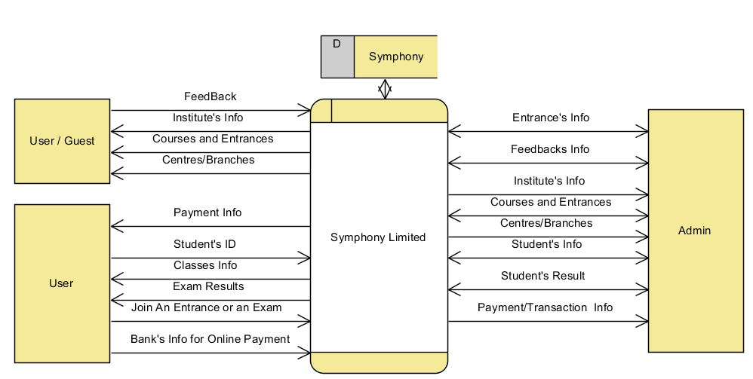

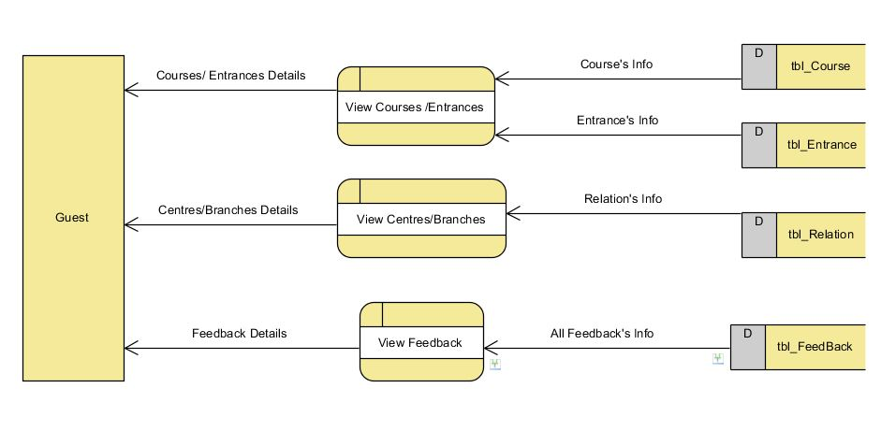

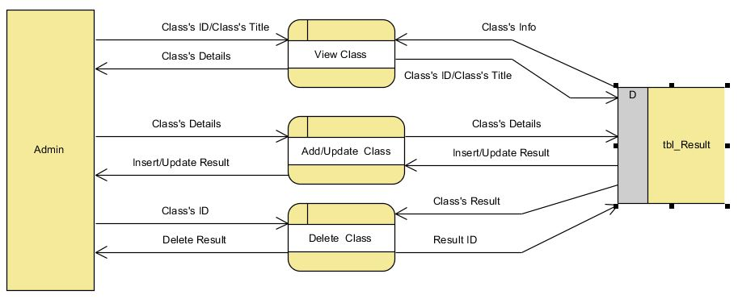

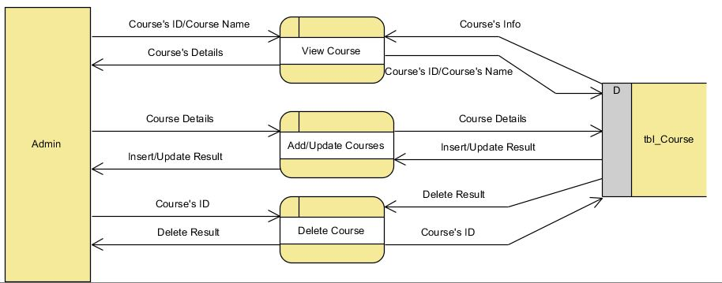

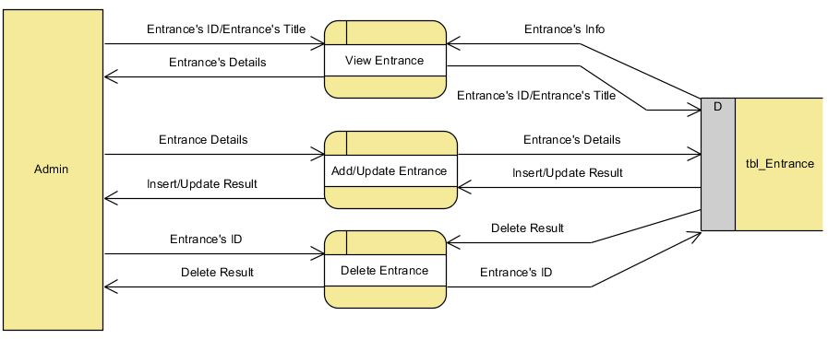

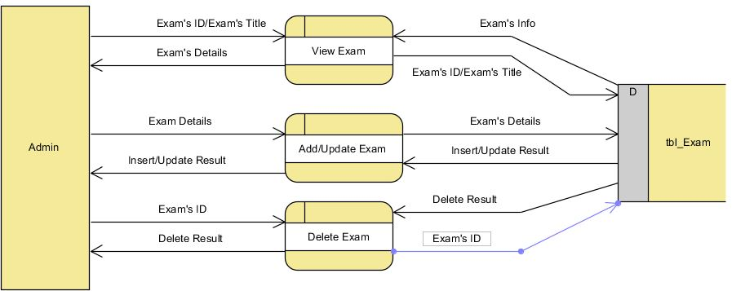

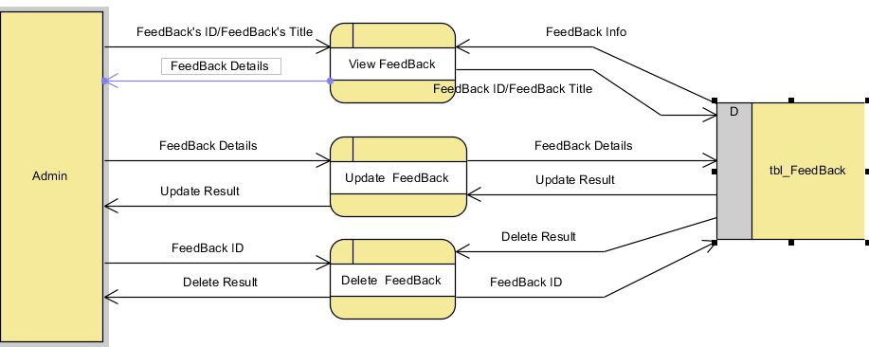

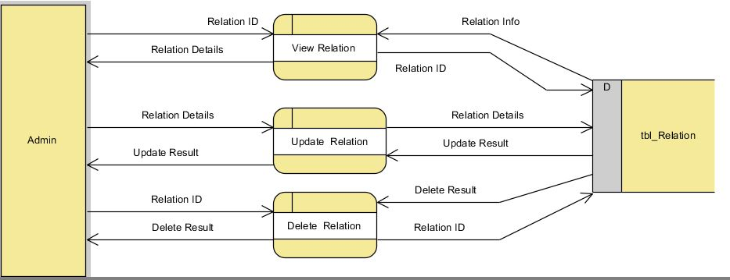

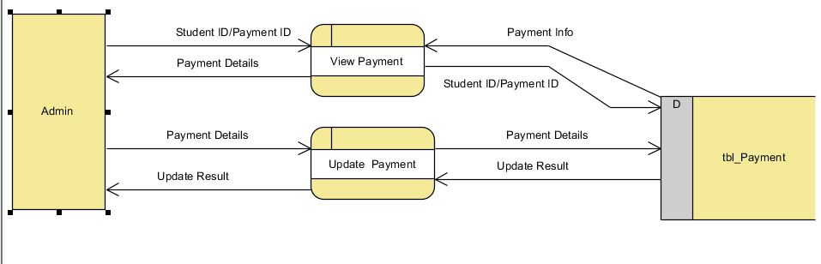

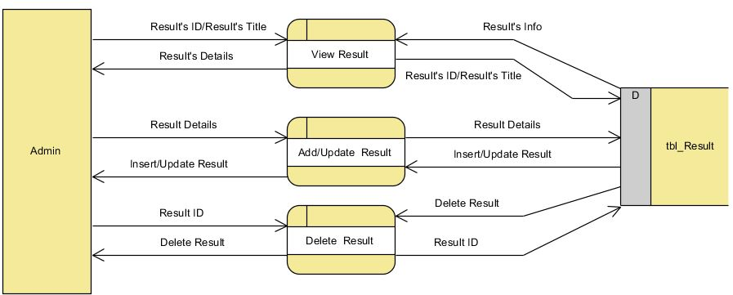

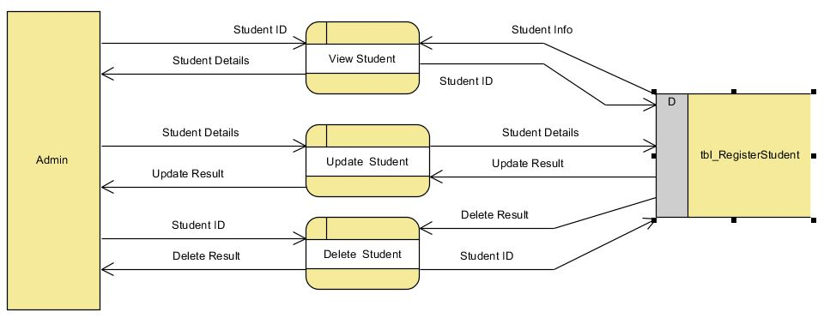

1. **USE CASE DIAGRAM**

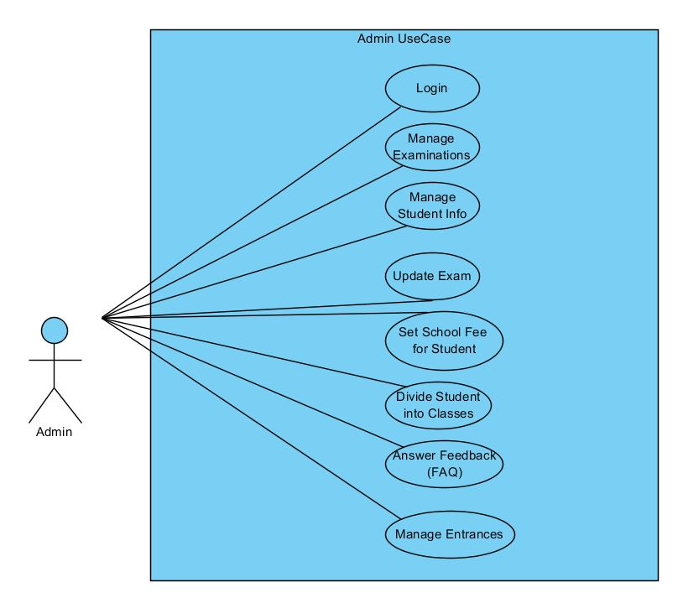

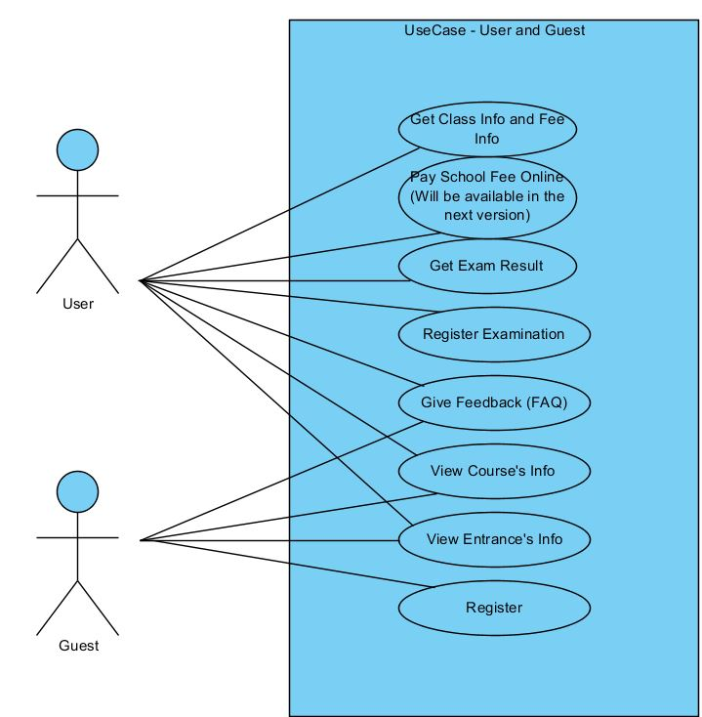

1. **USECASE DESCRIPTION**

**List Actor**

|  |  |  |
| --- | --- | --- |
| **No** | **Name** | **Description** |
| 1 | Admin | Admin Website |
| 2 | User | Customer |
| 3 | Guest | Viewer |

**List Use Case**

|  |  |  |
| --- | --- | --- |
| **No** | **Name** | **Description** |
| 1 | Login Admin page | Admin login to control Website |
| 2 | Manage Examinations | Admin can add, view, edit and delete Exam’s Information |
| 3 | Manage Student Info | Admin can view, edit and delete User’s Information |
| 4 | Add School Fee | Admin can Add School Fee |
| 5 | Divide student into class | Admin can arrange the student to the class |
| 6 | Answer Feedback | Admin can read Feedback from User ,Answer , Accept or deny it also can delete it (only Feedback is denied) |
| 7 | Manage Entrances | Admin can view, add, edit and delete Entrance’s information |
| 8 | Register | User register Account |
| 9 | View Entrance | User, Guest can view Entrance’s information |
| 10 | View Course | User, Guest can view Course’s information |
| 11 | Question FAQ’s | User, Guest can send Feedback to Admin |
| 12 | Search Result Exam | User use Website to search his/her’s result exam |
| 13 | Pay school fee online | User can use Website to pay school fee |
| 14 | View order class and school fee | User can use Website to view Order class and school fee |

**Description**

Use-case Manage Examinations

|  |  |
| --- | --- |
| Use-case | View Product’s Information |
| Short Description | After Login Admin will see all Exam’s information |
| Pre-Conditions |  |
| Post-Conditions |  |
| Main flow | Admin can Add, Edit, Delete exam by Center’s request |
| Alternative flow(s) | If server notifies any error when it’s processing, system must be write report into Log file. |

Use-case Manage Student info

|  |  |
| --- | --- |
| Use-case | View Product’s Information |
| Short Description | After Login Admin will see all User Information |
| Pre-Conditions |  |
| Post-Conditions |  |
| Main flow | Admin can Edit, Delete user if they quit , drop out, want to learn new class or special issue |
| Alternative flow(s) | If server notifies any error when it’s processing, system must be write report into Log file. |

Use-case Add School fee

|  |  |
| --- | --- |
| Use-case | View Product’s Information |
| Short Description | After login Admin can insert school fee |
| Pre-Conditions |  |
| Post-Conditions |  |
| Main flow | Admin can add new school fee by Center’s request |
| Alternative flow(s) | If server notifies any error when it’s processing, system must be write report into Log file. |

Use-case Divide student into class

|  |  |
| --- | --- |
| Use-case | View Product’s Information |
| Short Description | After login Admin will see User’s information |
| Pre-Conditions |  |
| Post-Conditions |  |
| Main flow | Admin can edit class where the student will study |
| Alternative flow(s) | If server notifies any error when it’s processing, system must be write report into Log file. |

Use-case Answer Feedback

|  |  |
| --- | --- |
| Use-case | View Product’s Information |
| Short Description | After Login Admin can see all Feedback |
| Pre-Conditions |  |
| Post-Conditions |  |
| Main flow | -Admin Accept benefit Feedback  -Admin deny Feedback which not follow Website’s Rule and Delete it  -Admin can Answer Feedback |
| Alternative flow(s) | If server notifies any error when it’s processing, system must be write report into Log file. |

Use-case Manage Entrances

|  |  |
| --- | --- |
| Use-case | View Product’s Information |
| Short Description | After Login Admin can see Entrance’s information |
| Pre-Conditions |  |
| Post-Conditions |  |
| Main flow | -Admin can Add, Delete, Edit entrance’s information by Center’s request |
| Alternative flow(s) | If server notifies any error when it’s processing, system must be write report into Log file. |

Use-case Register

|  |  |
| --- | --- |
| Use-case | View Product’s Information |
| Short Description | Guest can register to become student(user) |
| Pre-Conditions |  |
| Post-Conditions |  |
| Main flow | -Guest can register to become student |
| Alternative flow(s) | If server notifies any error when it’s processing, system must be write report into Log file. |

Use-case View Information Entrance

|  |  |
| --- | --- |
| Use-case | View Product’s Information |
| Short Description | Guest, User can see all Entrance’s information |
| Pre-Conditions |  |
| Post-Conditions |  |
| Main flow | - Guest, User can see all Entrance’s information on the website |
| Alternative flow(s) | If server notifies any error when it’s processing, system must be write report into Log file. |

Use-case View Information Course

|  |  |
| --- | --- |
| Use-case | View Product’s Information |
| Short Description | Guest, User can see all Course’s information |
| Pre-Conditions |  |
| Post-Conditions |  |
| Main flow | - Guest, User can see all Course’s information on the website |
| Alternative flow(s) | If server notifies any error when it’s processing, system must be write report into Log file. |

Use-case Question FAQ’s

|  |  |
| --- | --- |
| Use-case | View Product’s Information |
| Short Description | Guest, User can send the question FAQ’s to Admin |
| Pre-Conditions |  |
| Post-Conditions |  |
| Main flow | User, Guest can send the question to admin. If they accept, they will send the answer else they delete that question |
| Alternative flow(s) | If server notifies any error when it’s processing, system must be write report into Log file. |

Use-case Pay School fee online

|  |  |
| --- | --- |
| Use-case | View Product’s Information |
| Short Description | Guest may sign up for an account to get the benefits of user. |
| Pre-Conditions |  |
| Post-Conditions |  |
| Main flow | Guest may sign up for an account to get the benefits of user. |
| Alternative flow(s) | If server notifies any error when it’s processing, system must be write report into Log file. |

Use-case Search Result Exam

|  |  |
| --- | --- |
| Use-case | View Product’s Information |
| Short Description | After login user can search his/her exam result |
| Pre-Conditions |  |
| Post-Conditions |  |
| Main flow | User can search the result on the website |
| Alternative flow(s) | If server notifies any error when it’s processing, system must be write report into Log file. |

Use-case View order class and school fee

|  |  |
| --- | --- |
| Use-case | View Product’s Information |
| Short Description | After login user can see all information about order class and school fee |
| Pre-Conditions |  |
| Post-Conditions |  |
| Main flow | After login user can see all information about order class and school fee |
| Alternative flow(s) | If server notifies any error when it’s processing, system must be write report into Log file. |

1. **SEQUENCE DIAGRAM**

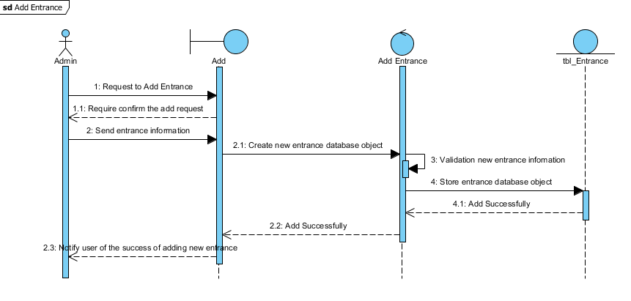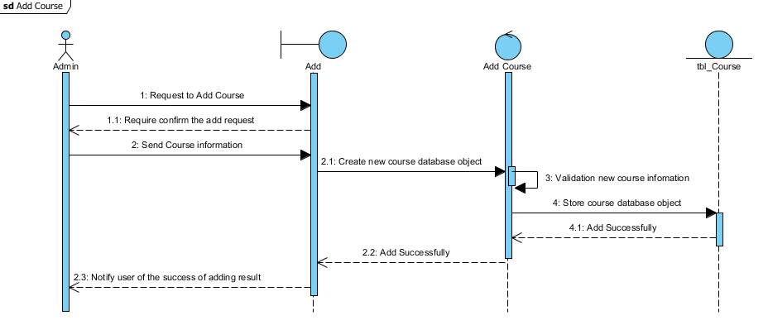

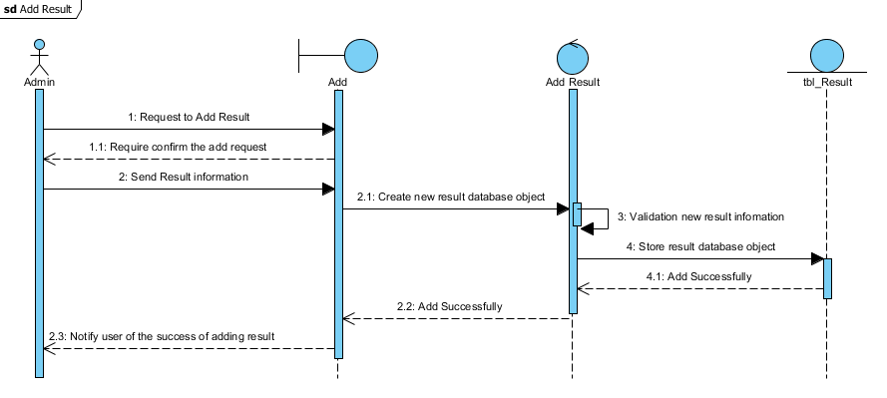

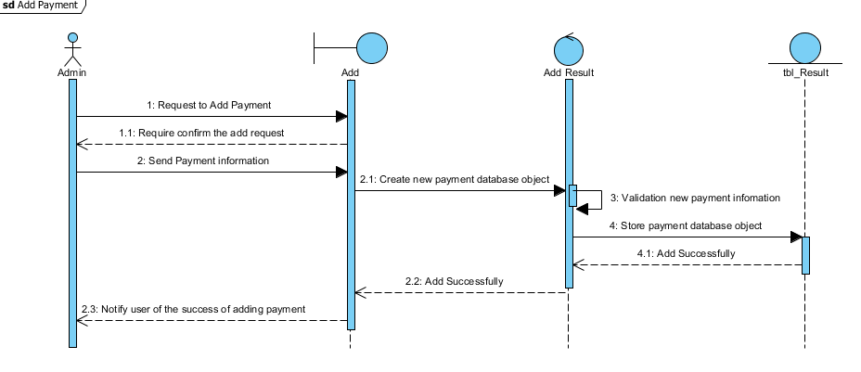

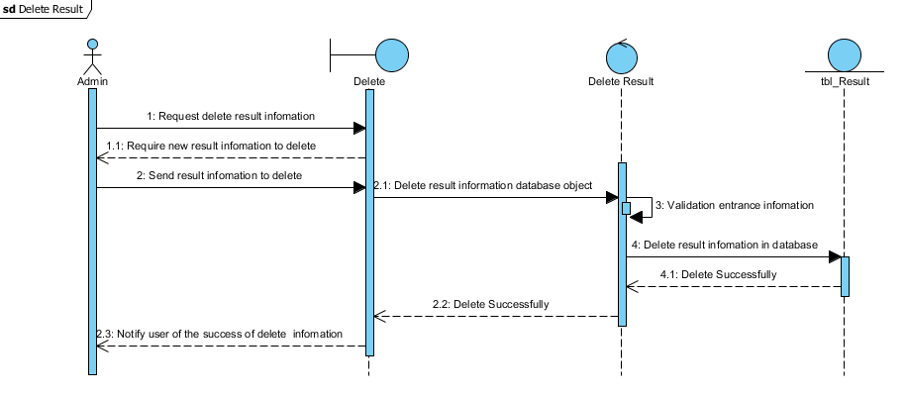

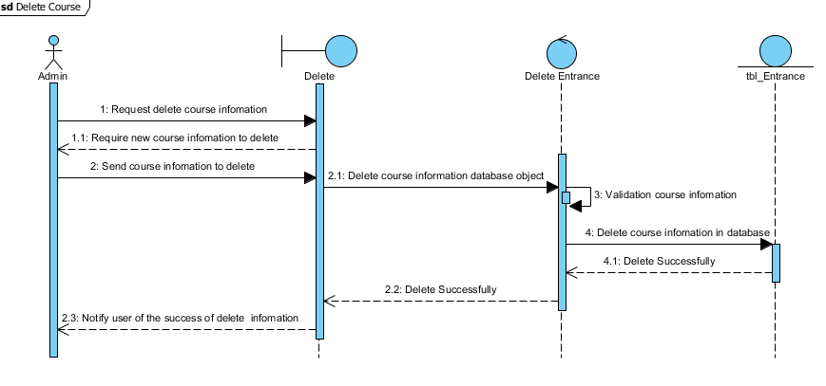

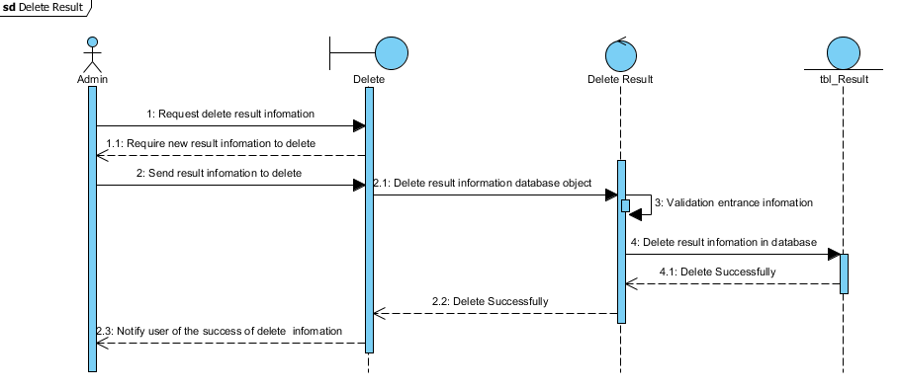

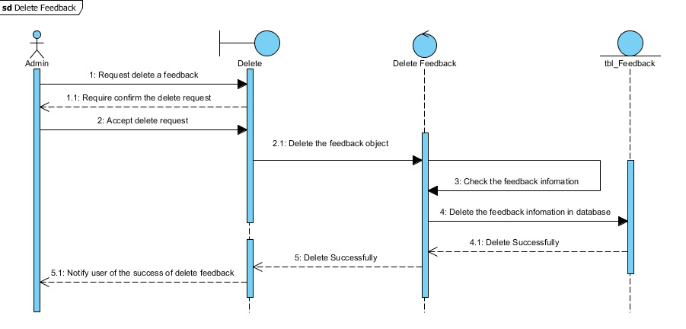

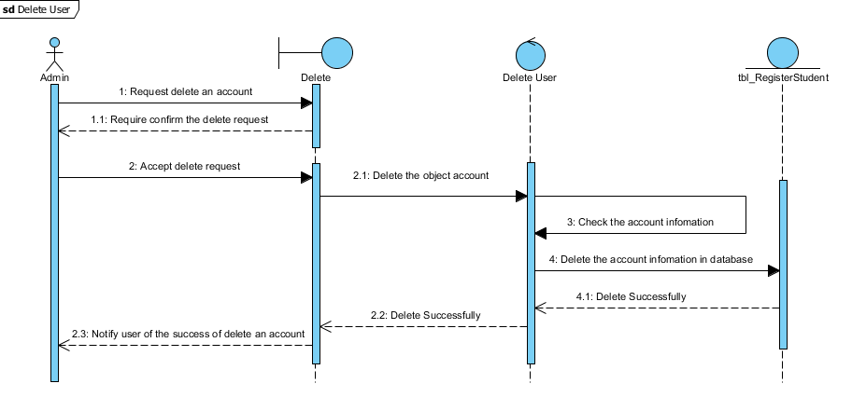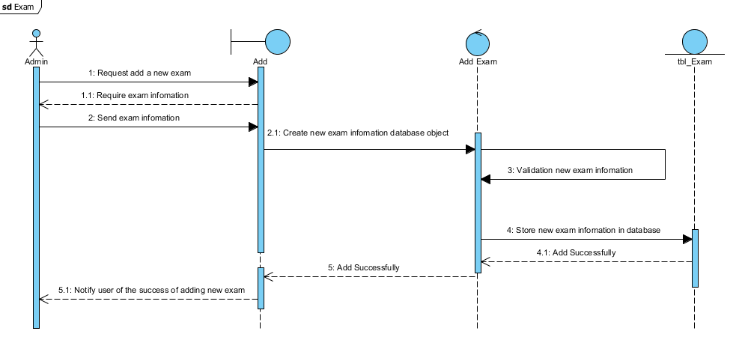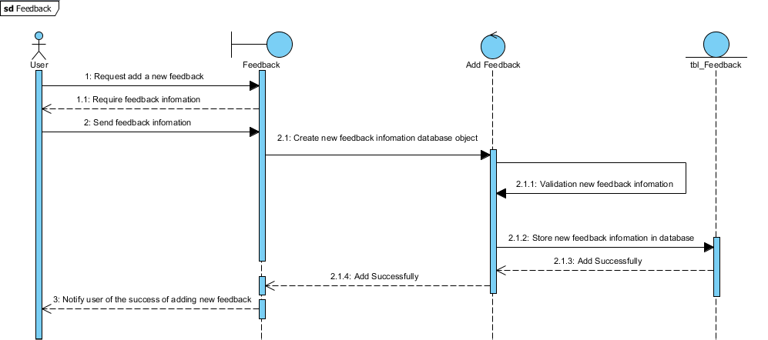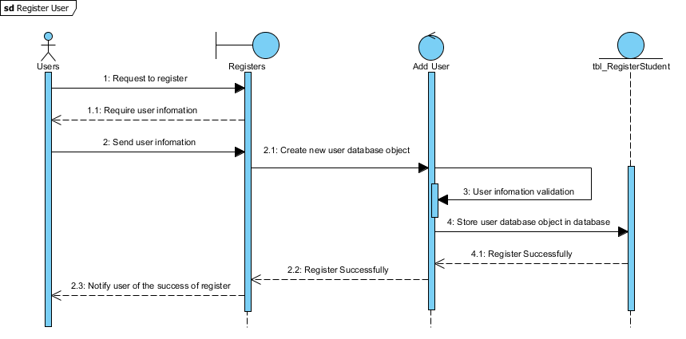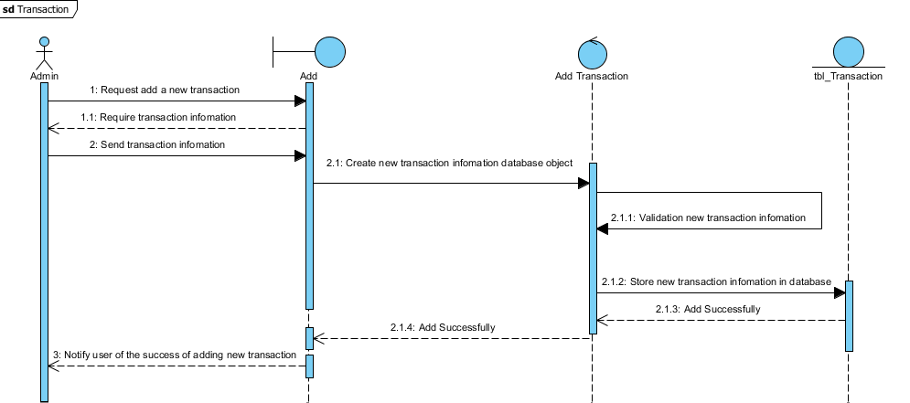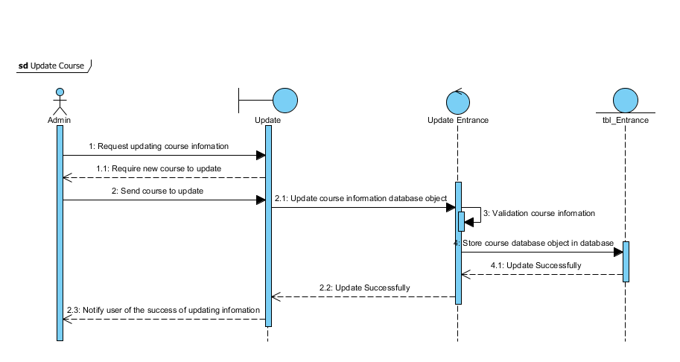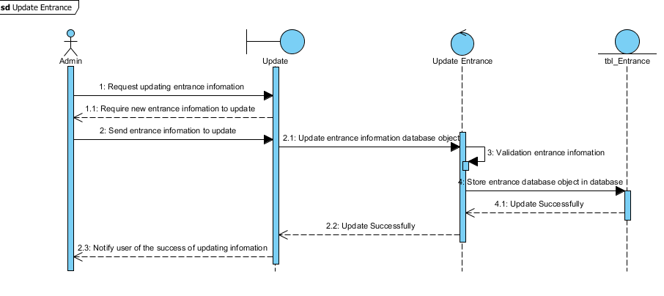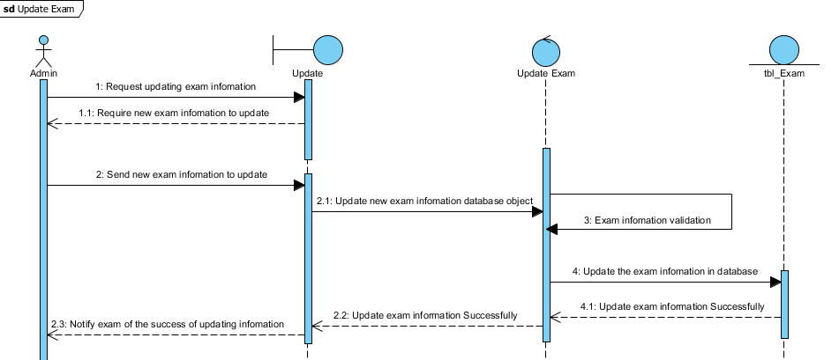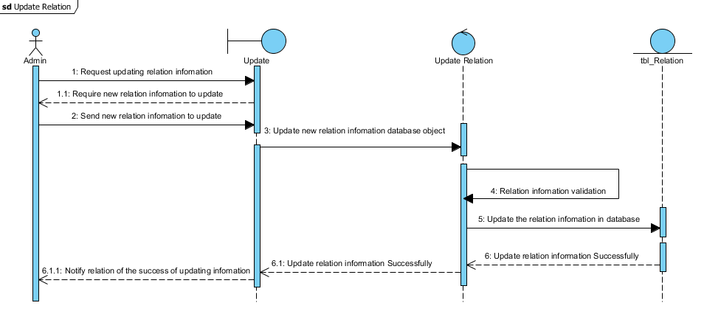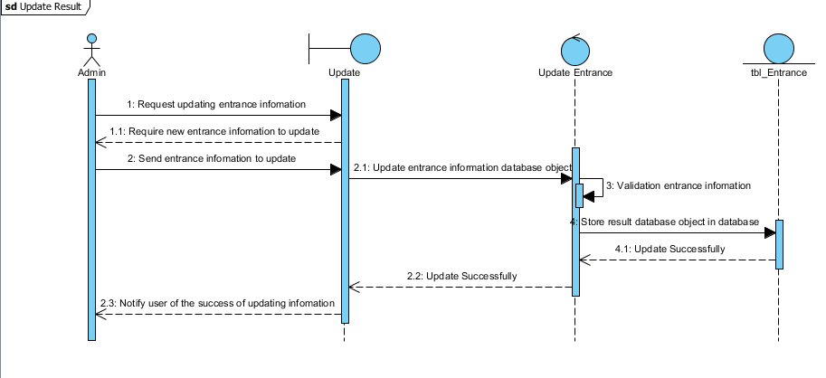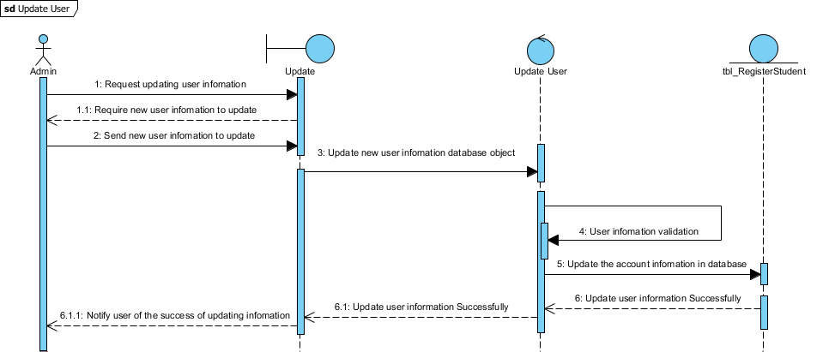

1. **ENTITY RELATIONSHIP DIAGRAM**

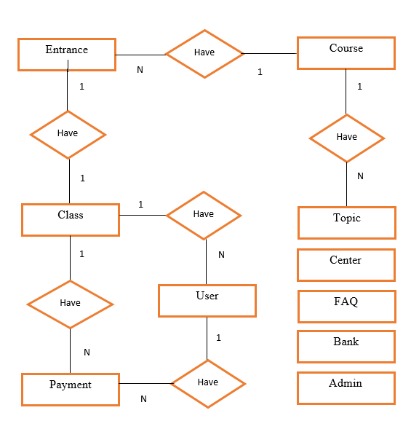

1. **ENTITY PROPERTIES**
2. Properties of tblClass

*tblClass*

1. Properties of tblFAQ

*tblFAQ*

1. Properties of tblUser

*tblUser*

1. Properties of tblBank

*tblBank*

1. Properties of tblPayment

*tblPayment*

1. Properties of tblCourse

*tblCourse*

topicID

*e*

1. Properties of tblTopic

*tblTopic*

1. Properties of tblAdmin

*tblAdmin*

1. Properties of tblEntrance

*tblEntrance*

1. Properties of tblCenter

*tblCenter*

1. **TABLE DESIGN**

|  |  |  |  |  |  |
| --- | --- | --- | --- | --- | --- |
| Table | **Field Name** | **Data Type** | **Allow Null** | **Key** | **Description** |
| tblUser | userID | varchar(50) | No | PK | Stores Username of Student |
| userpass | varchar(50) | No |  | Stores Password of Student |
| userFullName | varchar(50) | No |  | Stores Name of Student |
| userSex | varchar(50) | No |  | Stores Sex of Student |
| userDOB | datetime | No |  | Stores Date Of Birth of Student |
| userEmail | varchar(50) | No |  | Stores Email of Student |
| classID | varchar(50) | Yes | FK | Stores ID Class of Student |
| practiceSession | int | Yes |  | Stores if practice session is available |
| entranceMark | int | Yes |  | Stores Mark entrance of Student |
|  | | | | | |
| tblTopic | topicID | varchar(50) | No | PK | Stores ID of Topic |
| courseID | varchar(50) | No | FK | Stores ID of Course |
| topicName | varchar(50) | Yes |  | Stores Name of Topic |
| topicDes | varchar(Max) | Yes |  | Stores description of Topic |
|  | | | | | |
| tblCourse | courseID | varchar(50) | No | PK | Stores ID of Course |
| courseName | varchar(50) | No |  | Stores Name of Course |
| courseFee | money | Yes |  | Stores Fee of Course |
|  | | | | | |
| tblEntrance | entranceID | varchar(50) | No | PK | Stores ID of Entrance |
| entranceTitle | varchar(50) | No |  | Stores Title of Entrance |
| entranceFee | money | Yes |  | Stores Fee of Entrance |
| entranceDate | date | Yes |  | Stores date entrance of Entrance |
| courseID | varchar(50) | No | FK | Stores ID of Course |
| endDate | date | Yes |  | Stores end date Entrance of Entrance |
|  | startDate | date | Yes |  | Stores start date Entrance of Entrance |
|  | | | | | |
| tbl_Payment | payID | int | No | PK | Stores ID of Payment |
| AccID | varchar(50) | No |  | Stores Account ID of Student |
| userID | varchar(50) | No | FK | Stores ID User of Student |
| classID | varchar(50) | Yes | FK | Stores ID Class of Student |
| payAmount | money | No |  | Stores Money Pay of Student |
| payDate | date | Yes |  | Stores Date Pay of Student |
| payType | varchar(50) | No |  | Store type Pay of Student |
| Is Paid | varchar(50) | No |  | Stores if the payment is paid |
|  | | | | | |
| tblCenter | centerID | varchar50) | No | PK | Stores ID of Relation Center |
| centerName | varchar50) | Yes |  | Stores Name of Relation Center |
| centerDes | varchar(max) | Yes |  | Store description of Center |
|  | | | | | |
| tblAdmin | adminID | varchar(50) | No | PK | Stores ID ofAdmin |
| adminPass | varchar(50) | No |  | Stores Pass of Admin |
|  | | | | | |
| tblFAQ | faqID | int | No | PK | Stores ID of FAQ(fast answer question) |
| faqEmail | varchar(50) | No |  | Stores Email of FAQ |
|  | faqQuestion | varchar(Max) | No |  | Stores Question of FAQ |
|  | faqAnswer | varchar(Max) | Yes |  | Stores Answer of FAQ |
|  | | | | | |
| tblClass | classID | varchar(50) | No | PK | Stores ID of Class |
| entranceID | varchar(50) | No | FK | Stores ID entrance of Class |
| startDate | date | Yes |  | Stores start date of Student |
| tblBank | AccountID | int | No | PK | Stores AccountID of bank user |
|  | PinCode | int | No |  | Stores pincode of bank user |
|  | Balance | money | Yes |  | Stores balance of bank user |
|  | | | | | |

1. **DATABASE RELATIONSHIP DIAGRAM**

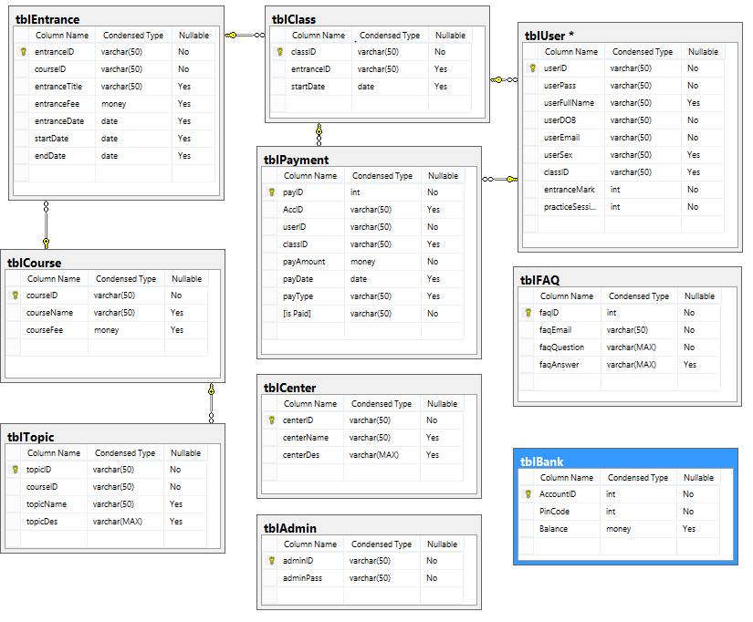

1. **CLASS DIAGRAM**

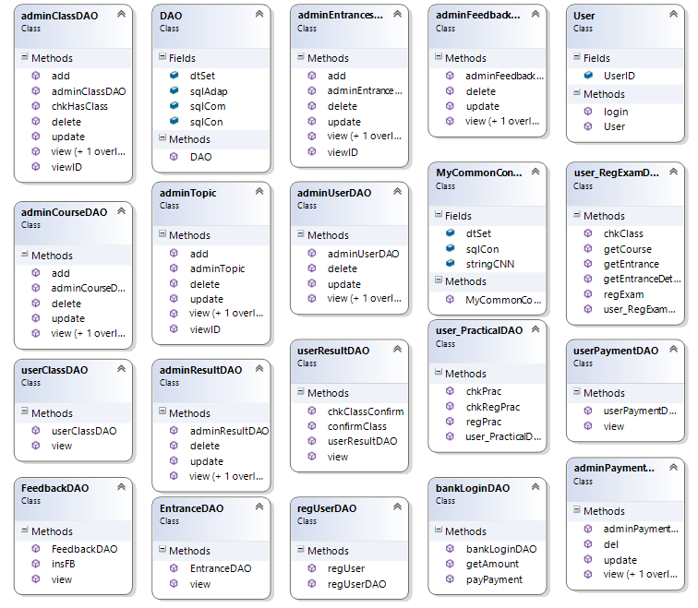

**Task Sheet 2**

|  |  |  |  |  |  |  |
| --- | --- | --- | --- | --- | --- | --- |
| **Project Title: Sajeevani Hospital Patient Management** | | | **Day of Prepare**  **of Activity Plan** | | | |
| **No.** | **Task** | **Description** | **Start**  **day** | **Complete day** | **Team Member Name** | **Status** |
| **1** | **Review** | **Architecture and Design of Project** | **23/10/2013** | **30/10/2013** | **Võ Minh Nhựt**  **Nguyễn Ngọc Kiều Trinh**  **Trần Nguyễn Công Nguyên**  **Đỗ Ngọc Quý** | **Complete** |
| **2** | **Data Flow Diagram** |
| **3** | **Entity Relationship Diagram** |
| **4** | **Flowchart** |
| **5** | **Database Relationship Diagram** |
| **6** | **Database Design/Structure** |
|  |  |  |  |  |  |  |

1. **FLOWCHARTS**
2. **Login**

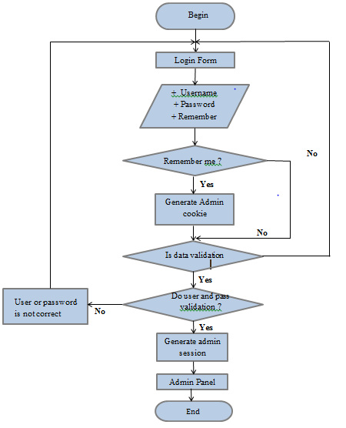

1. **Logout**

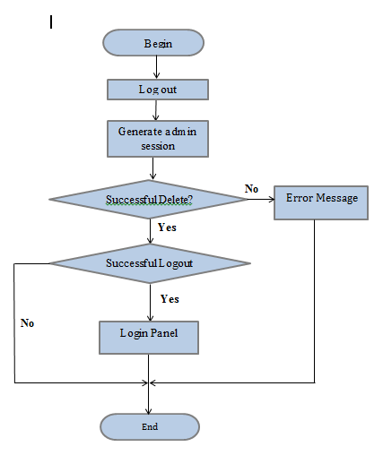

1. **View the person details**

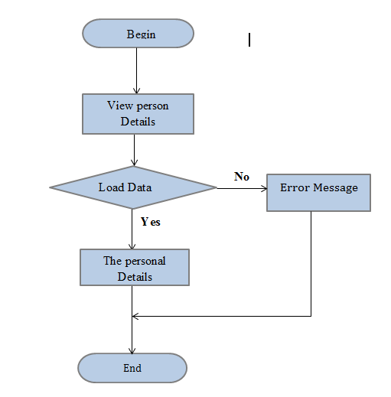

1. **Update the person details**

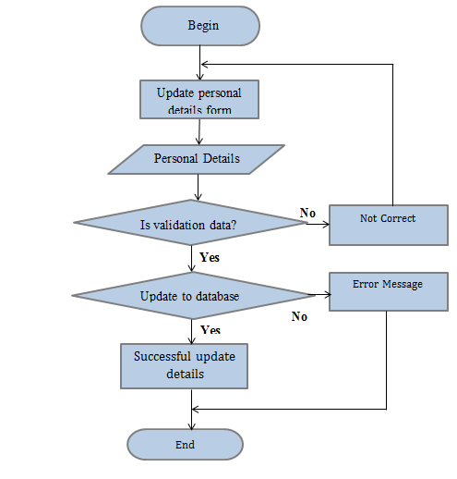

1. **Change password**

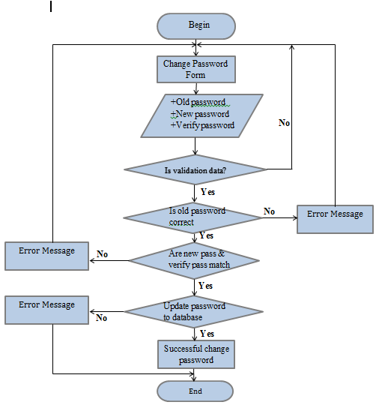

* **Course**

1. **View the details of course**

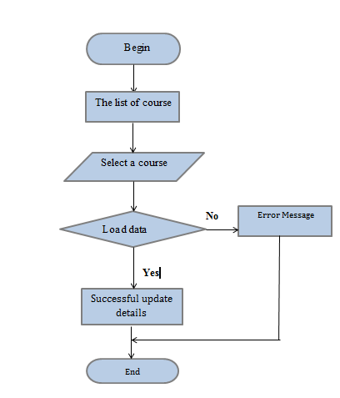

1. **Create the new the course**

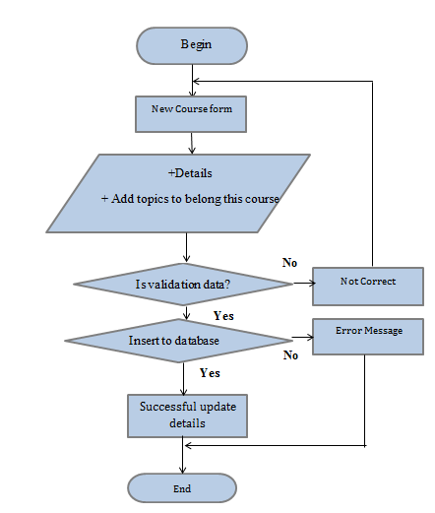

1. **Update the details of course**

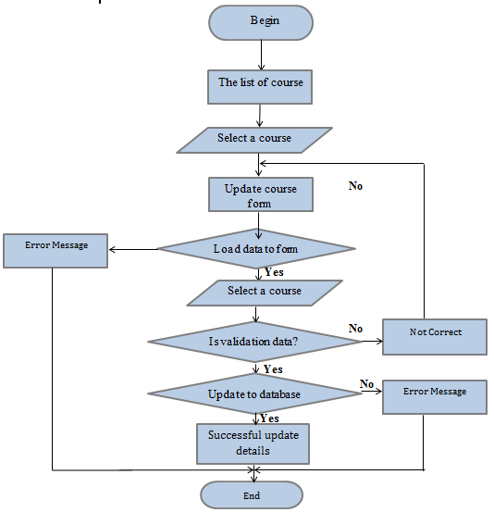

1. **Search course**

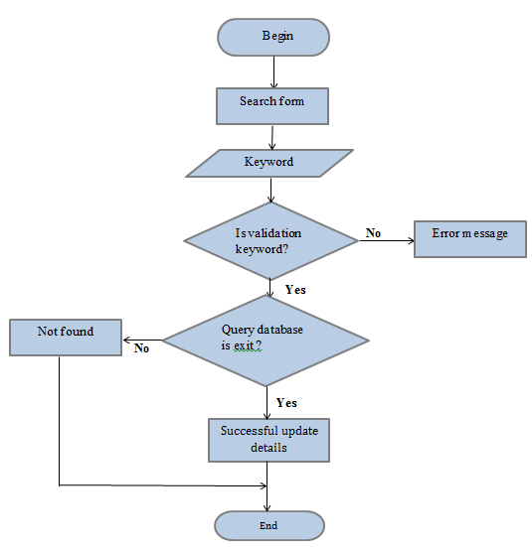

* **Entrance Exam**

1. **View the list of Entrance**

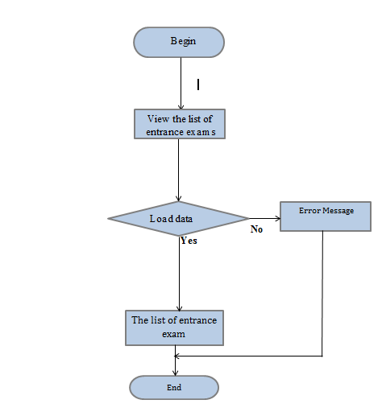

1. **Create the new Entrance**

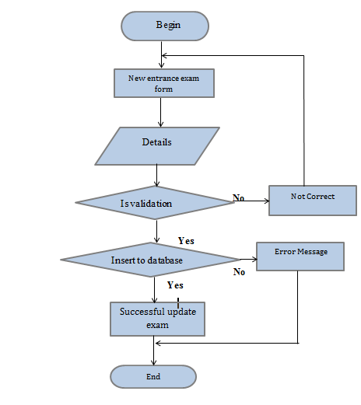

1. **Update Entrance ‘s information**

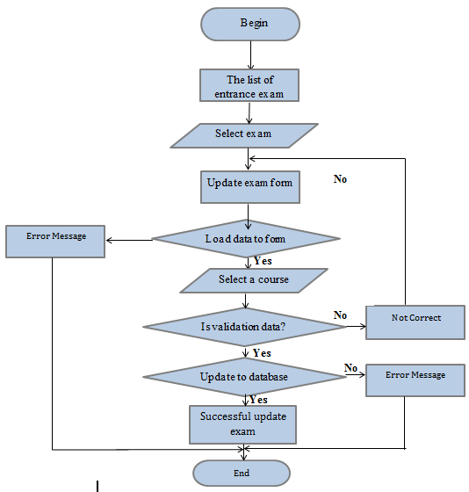

1. **Search entrance exam**

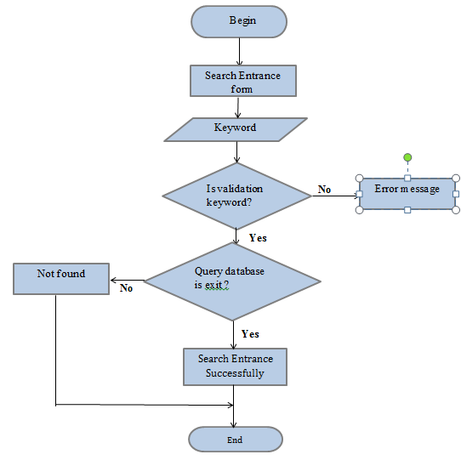

* **Center**

1. **View the list of the center**

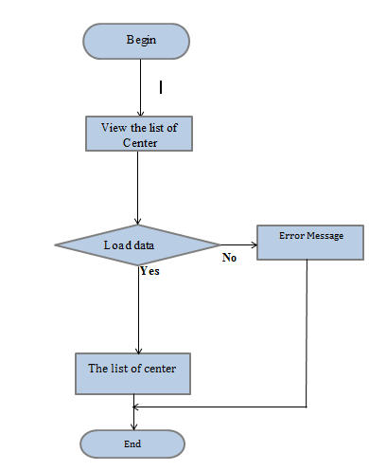

* **Admin manager user**

1. **Add the user with information**

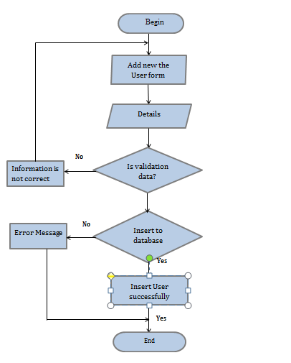

1. **Admin Update the user**

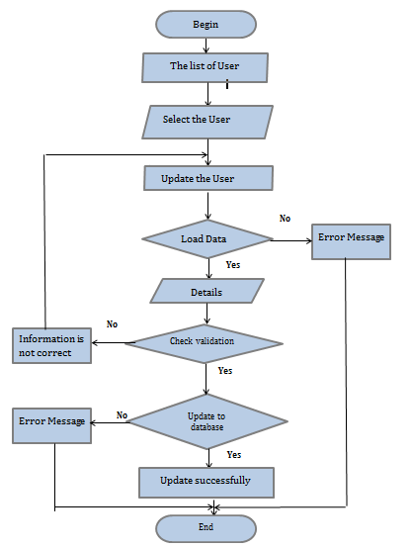

1. **Admin Delete user**

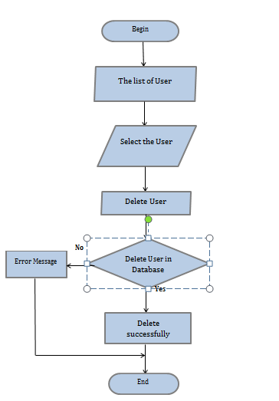

1. **Admin Search user**

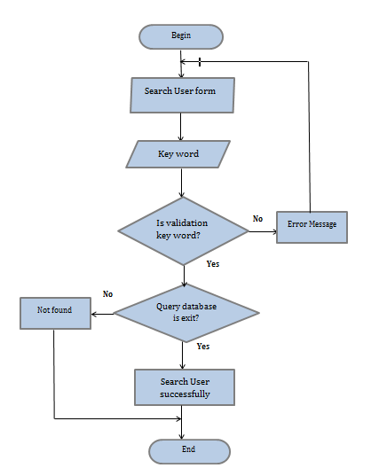

* **Feedback**

1. **View the list of feedback**

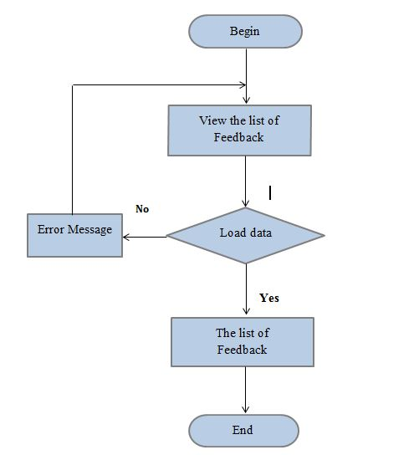

1. **Add the Feedback**

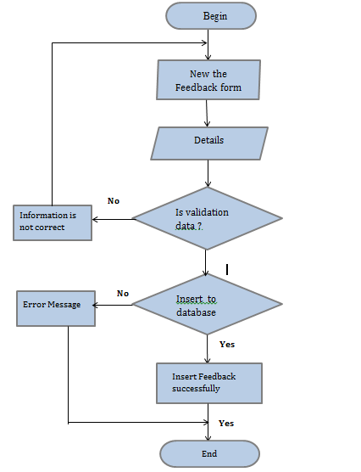

1. **Update the feedback**

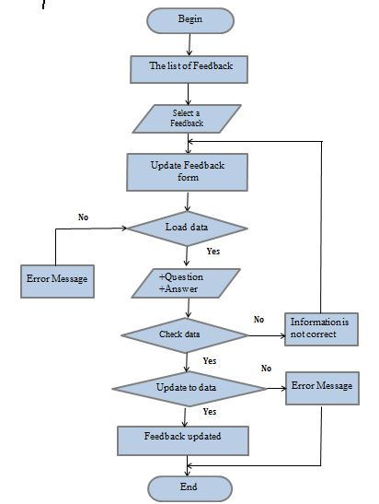

1. **Delete one or more Feedback**

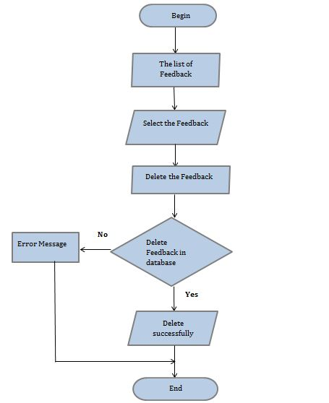

* **Topic**

1. **View the topic**

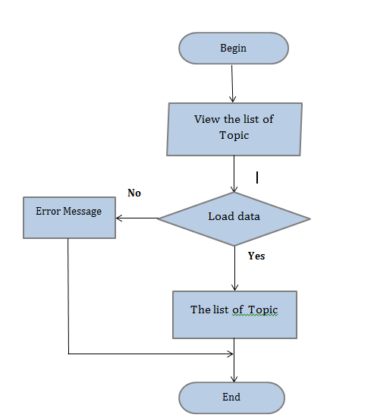

1. **Create the topic**

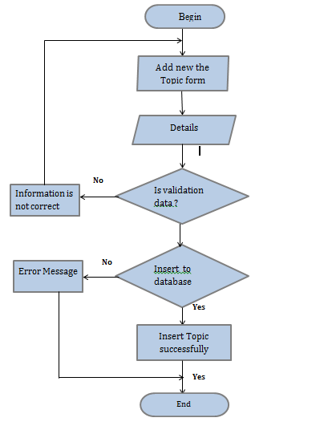

1. **Update the details topic**

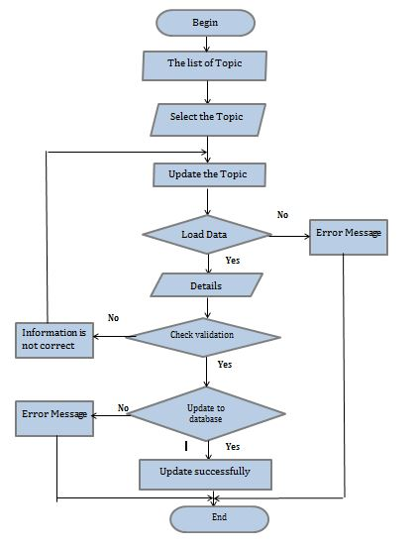

1. **Delete the topic**

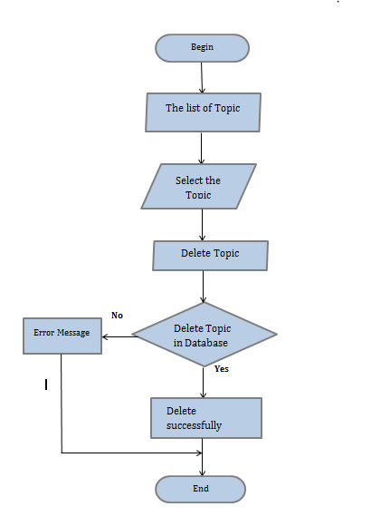

1. **Search a topic**

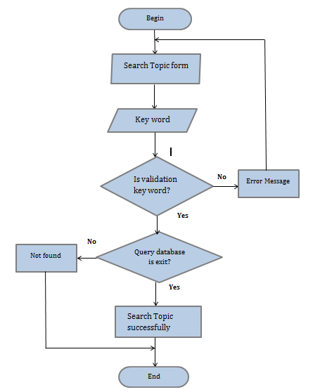

* **Payment**

1. **View the payment**

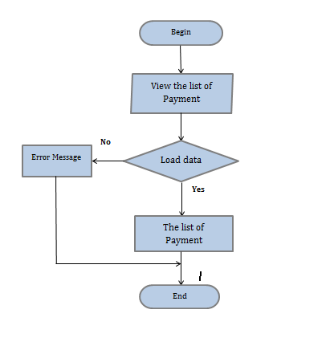

1. **Create the payment**

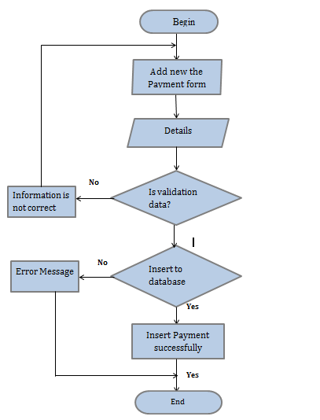

1. **Update the details payment**

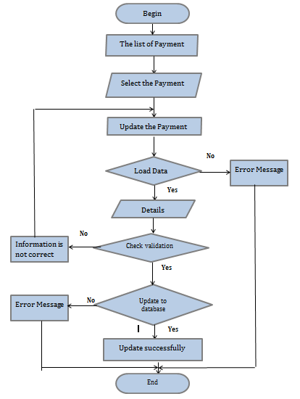

1. **Delete the payment**

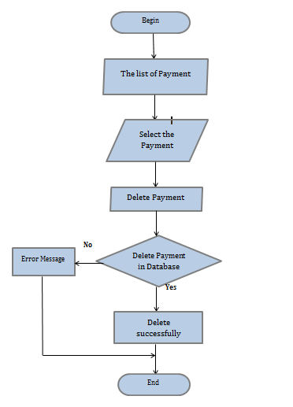

* **Class**

1. **View the class**

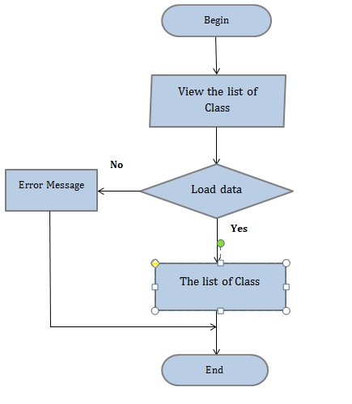

1. **Create the class**

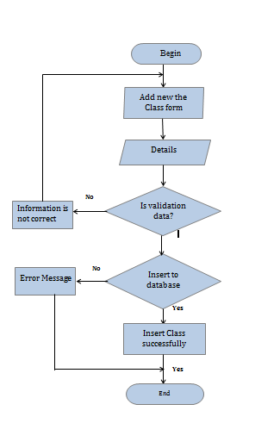

1. **Update the class**

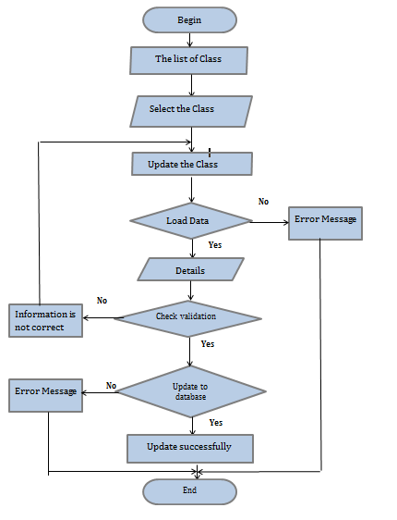

1. **Delete the class**

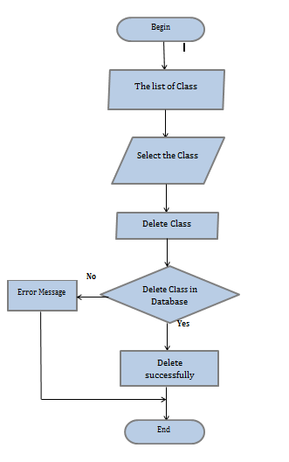

1. **Search a class**

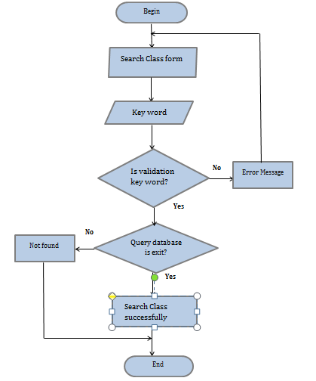

## SITEMAP

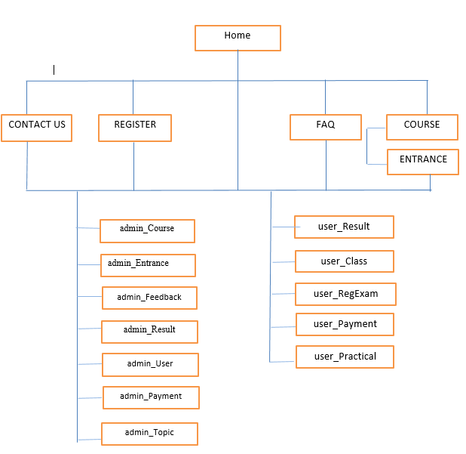

## GUIDE DESIGN

Bn 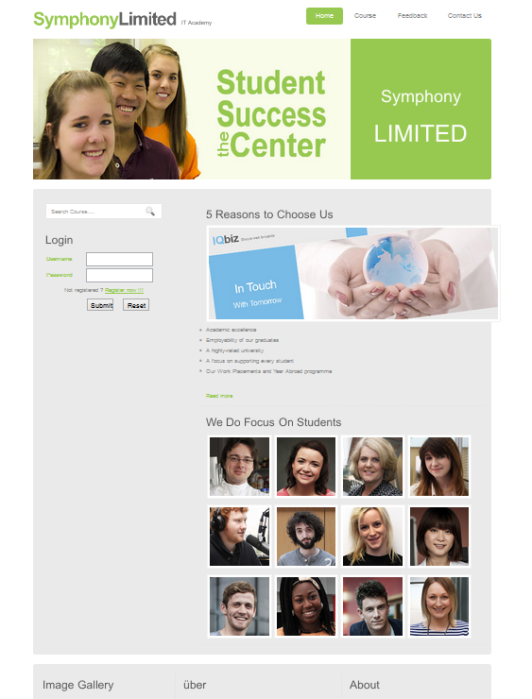

## Home.aspx

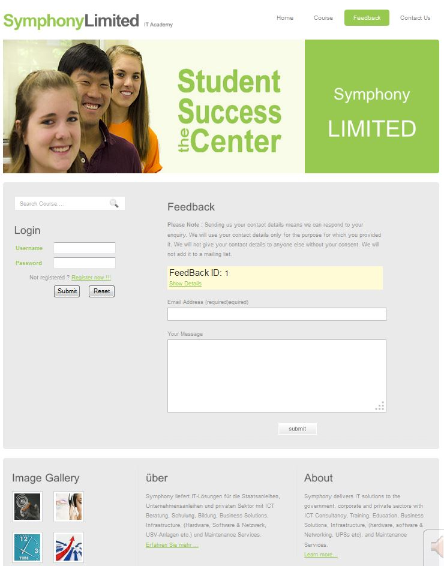

**Feedback.aspx**

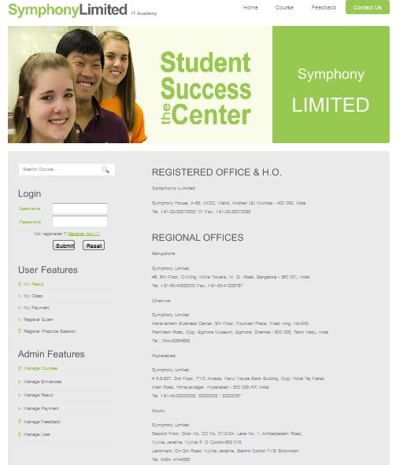

**ContactUs.aspx**

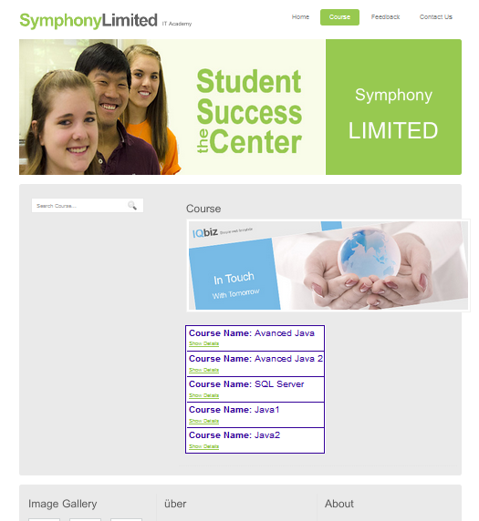

**Course.aspx**

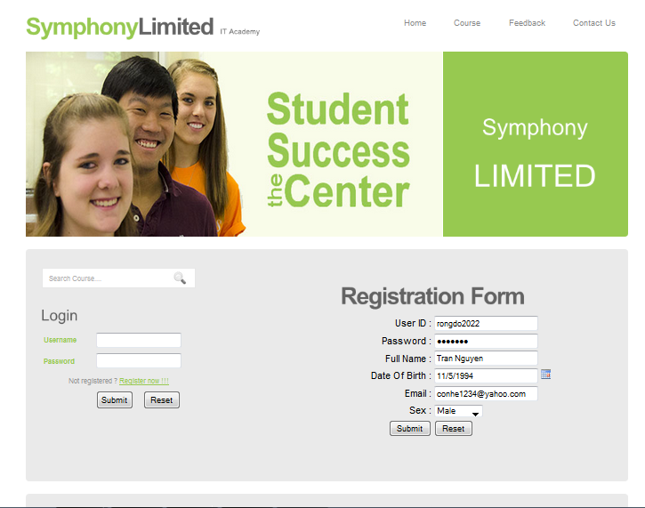

**regUser.aspx**

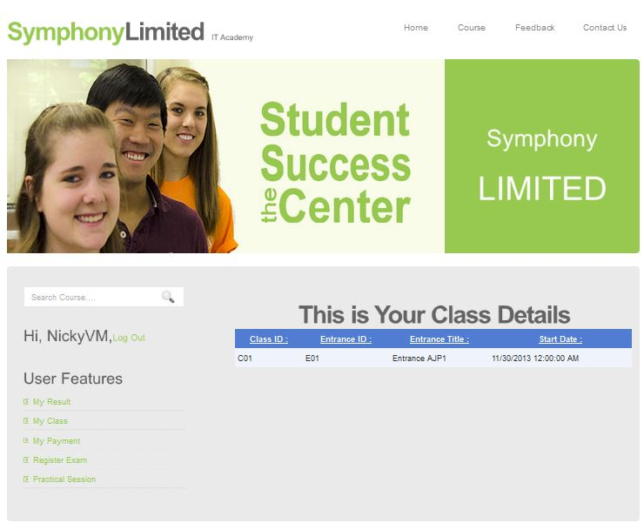

**User_Class.aspx**

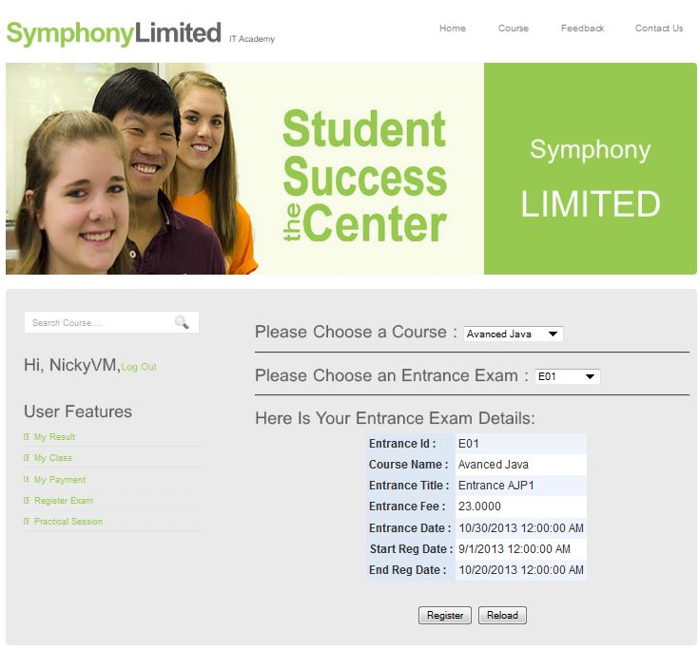

**User_RegExam.aspx**

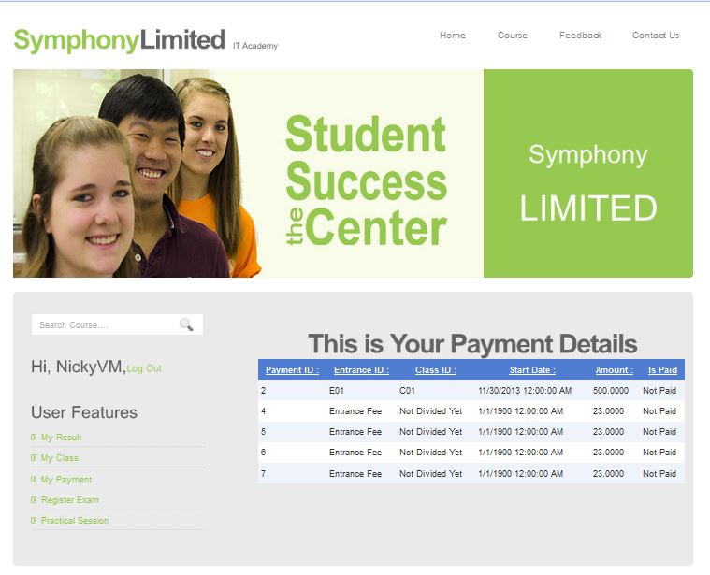

**User_Payment.aspx**

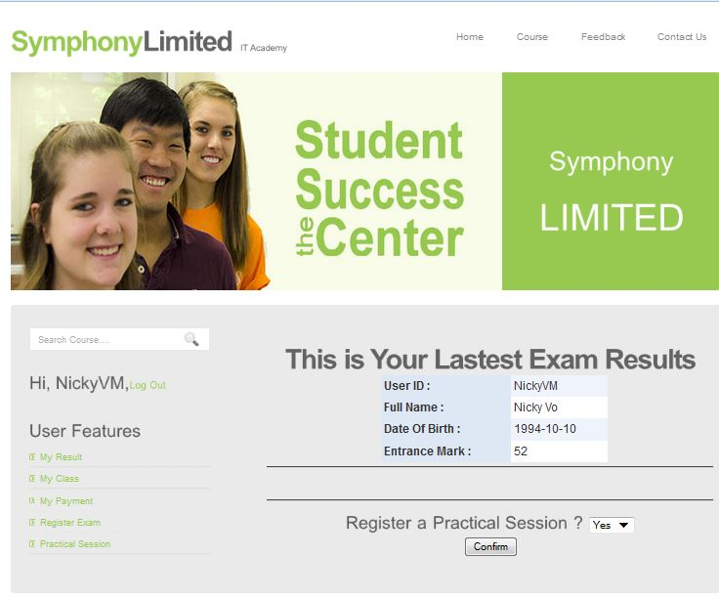

**User_Result.aspx**

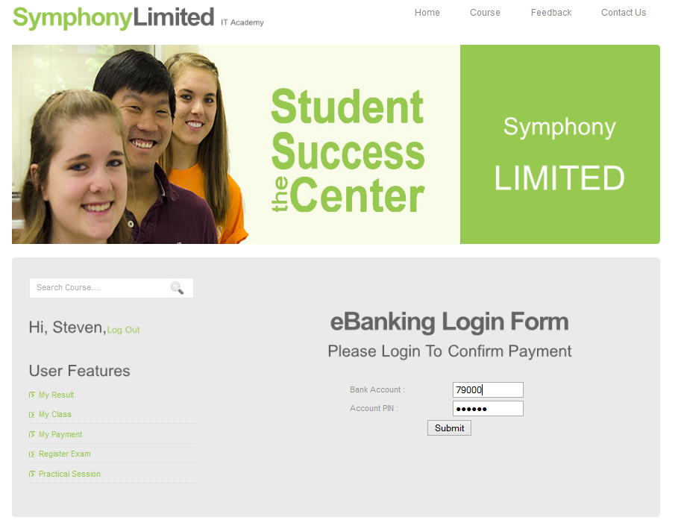

**bankLogin.aspx**

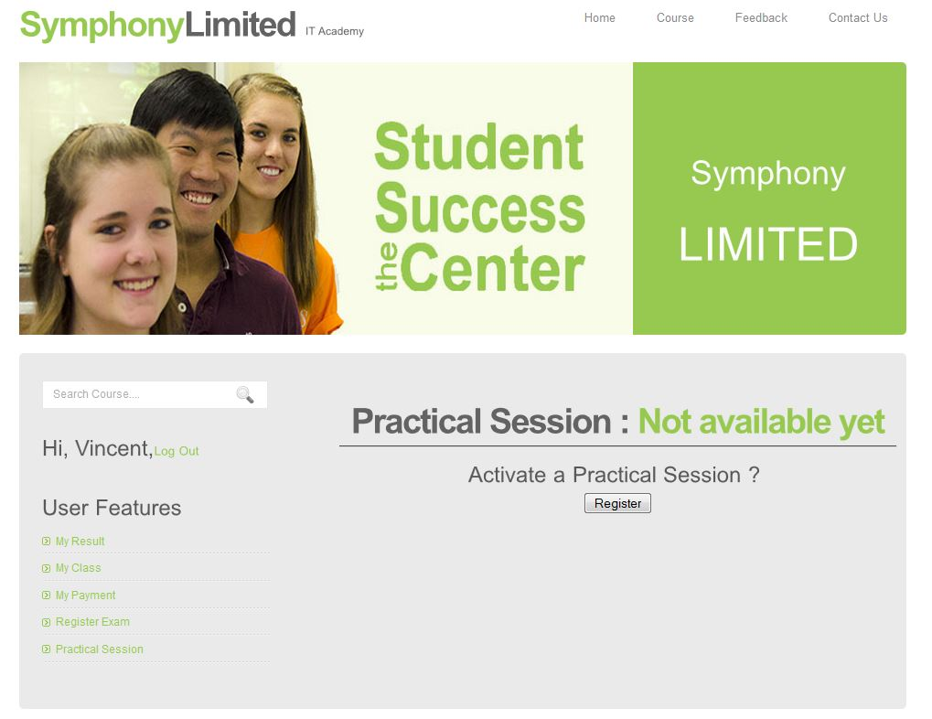

**User_Practical.aspx**

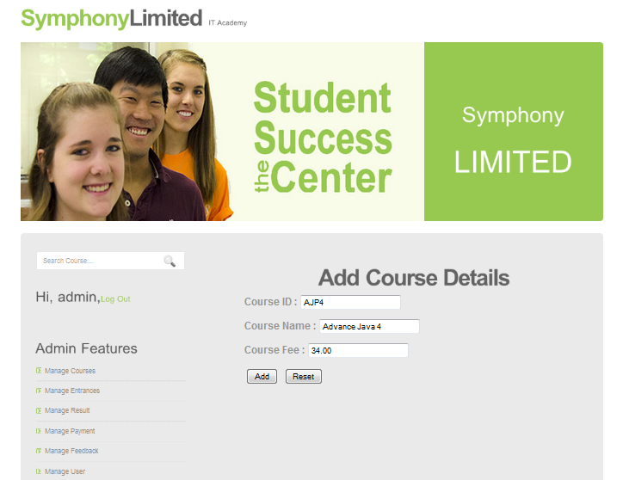

**AddCourse.aspx**

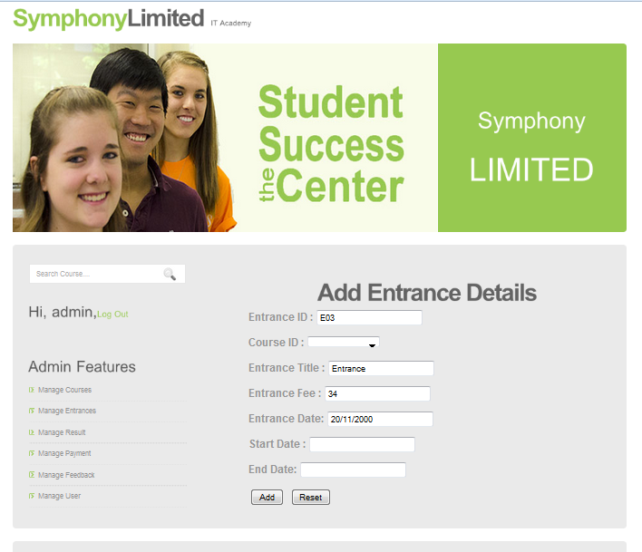

**AddEntrance.aspx**

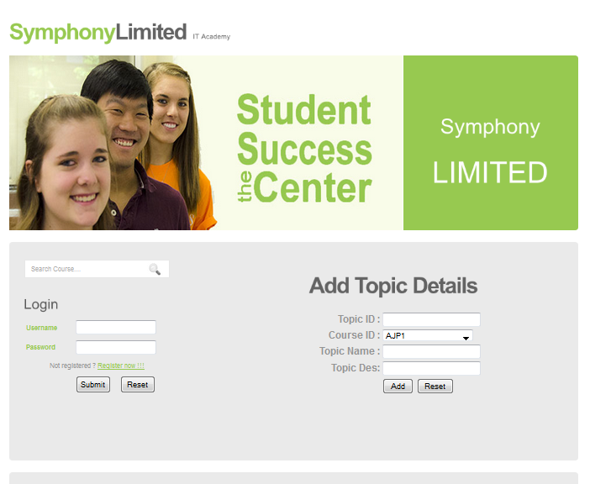

**AddTopic.aspx**

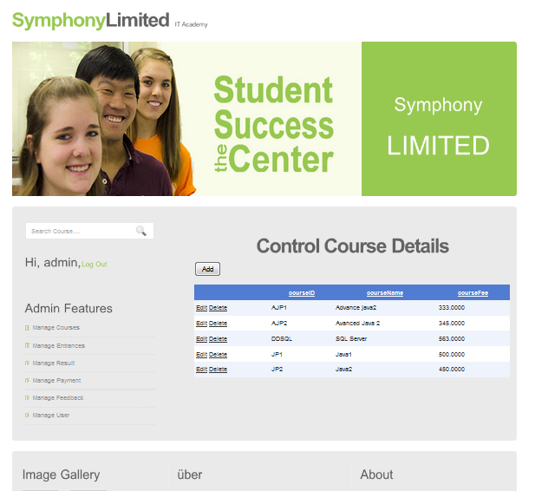

**Admin_Course.aspx**

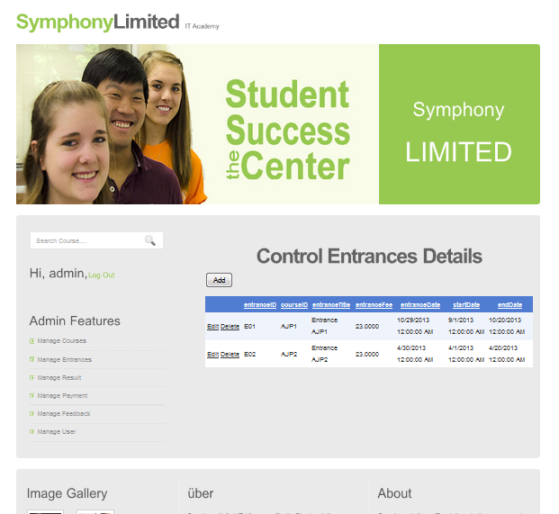

**Admin_Entrance.aspx**

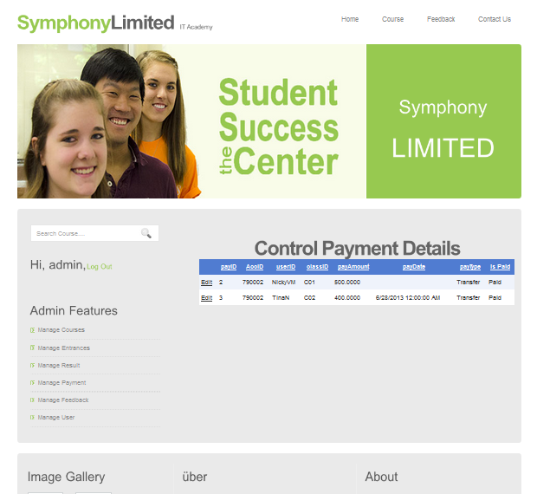

**Admin_Payment.aspx**

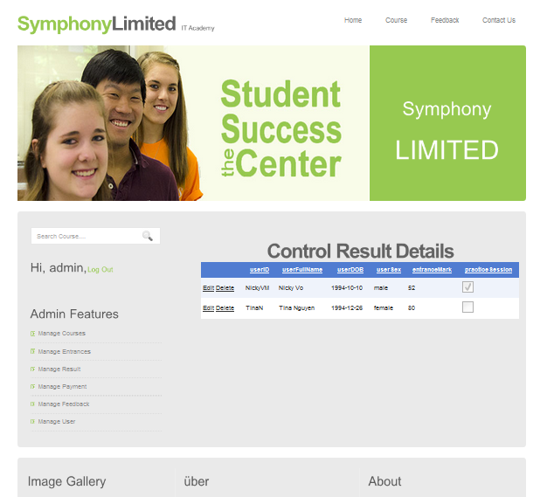

**Admin_Result.aspx**

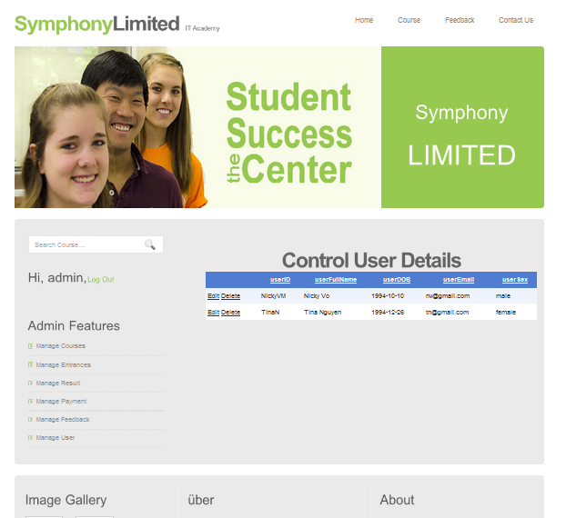

**Admin_User.aspx**

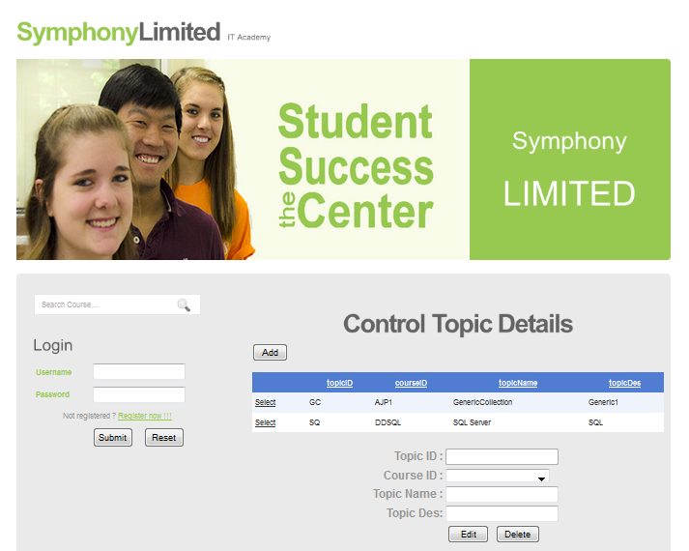

**Admin_Topic.aspx**

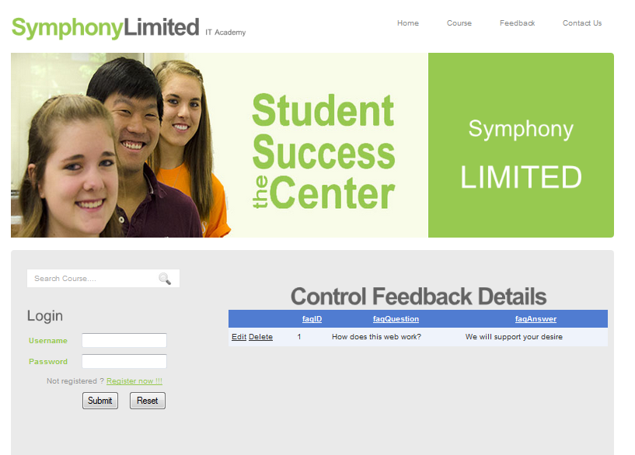

**Admin_Feedback.aspx**

## CHECK LIST OF VALIDATION

|  |  |
| --- | --- |
| **Option** | **Validated** |
| Do all numerric variables have default value of zero? | Yes |
| Does the administrator have all the rights to create and delete the records? | Yes |
| Are all the records properly fed into the approriate database? | Yes |
| Have all the modules been properly intergrated and are completely functional? | Yes |
| Have all the Design and Coding Standards been followed and implemented? | Yes |
| Is the GUI design considtent all over | Yes |
| Is exception handling mechanism implemented in all the screens? | Yes |
| Are all the program codes working? | Yes |

|  |  |  |  |  |  |
| --- | --- | --- | --- | --- | --- |
| **Sr.No.** | **Particulars** | **Yes** | **No** | **NA** | **Comments** |
| 1 | Are all the users able to search for a particular record? | Yes |  |  |  |
| 2 | Are all the old records properly saved and retrieved when required? | Yes |  |  |  |
| 3 | Have all the modules been properly intergrated and are completely functional? | Yes |  |  |  |
| 4 | Are the GUI contents devoid of spelling mistakes? | Yes |  |  |  |
| 5 | Is the application user-friendly? | Yes |  |  |  |
| 6 | Is the project published properly into a setup file? | Yes |  |  |  |

**Task Sheet 3**

|  |  |  |  |  |  |  |
| --- | --- | --- | --- | --- | --- | --- |
| Project Title: Symphony Limited | | | Day of prepare of Activity Plan | | | |
| **No.** | **Task** | **Description** | **Start day** | **Complete day** | **Team Member Name** | **Status** |
| 1 | **Review 3** | user_Class.aspx  user_Payment.aspx  user_RegExam.aspx  user_Result.aspx  user_Practical.aspx  AddCourse.aspx  Admin_Payment.aspx  bankLogin.aspx | 6/11/2013 | 10/11/2013 | **Võ Minh Nhựt** | **Completed** |
| 2 | regUser.aspx  Course.aspx  ContactUs.aspx  admin_Topic.aspx  admin_Class.aspx | **Nguyễn Ngọc Kiều Trinh** |
| 3 | Entrance.aspx  Masterpage.master  Admin_Course.aspx  Admin_Entrance.aspx  Admin_Feedback.aspx  AddEntrance.aspx | **Trần Nguyễn Công Nguyên** |
| 4 | Feedback.aspx  Admin_User.aspx  Home.aspx  Admin_Result.aspx  Style.css | **Đỗ Ngọc Quý** |